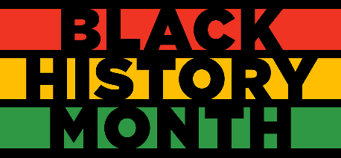
Middle School South

• Daily announcements highlight current Black Americans who are improving our planet, lives, and the lives of others.
• Science teachers across grade levels are highlighting black scientists who have influenced, and continue to influence, the scientific community.
• Social studies teachers are working with students to complete presentations about Black Americans who have impacted our country and the world – focusing on social justice, voting rights, human rights, and more.
• Our art teacher will be introducing students to Black artists throughout the month and providing students opportunities to create their own art in the impression of the Black artists highlighted.
• Our ESL classes are developing slides for our daily announcements highlighting different countries and cultures from where our students are from.
• Our RoX program is working with our RoX girls on how to navigate conversations around race and social justice. They will be completing two lessons this month titled, "Using My Voice" and "Strong Women Worth Defending." These lessons are presented to our RoX facilitator by Dr. Tina D. Pierce.

